EASTER DAY 2021

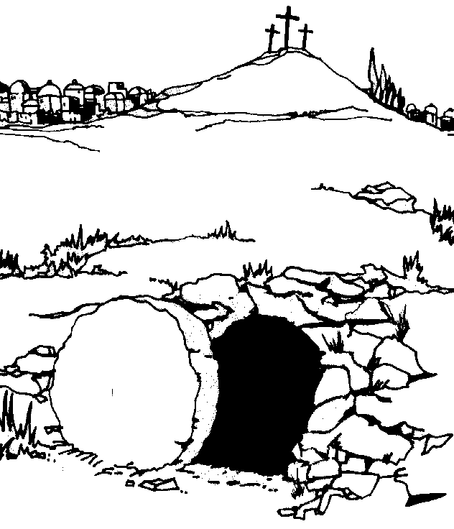

Beloved in Christ, on this most holy day, when our Lord Jesus Christ has passed over from death to life, the Church invites her people throughout the world to gather in prayer. This is the Passover of the Lord, in which, by hearing his word and celebrating his mysteries, we share in his victory over death and in life with him forever in God.

The Paschal candle is lit

Eternal God,
who made this most holy day
to shine with the brightness of your one true light:
set us aflame with the fire of your love,
and bring us to the radiance of your heavenly glory;
through Jesus Christ our Lord. Amen.

Incense grains are inserted into the candle with these words

Christ yesterday and today,
the beginning and the end,
Alpha and Omega,
all time belongs to him,
and all ages;
to him be glory and power,
through every age and forever. Amen.

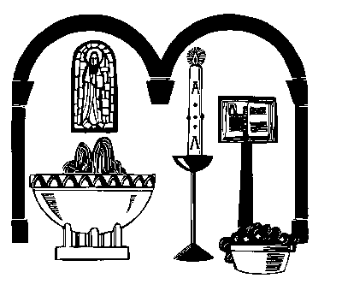
By his holy and glorious wounds may Christ our Lord guard and keep us. Amen.

The president lights the Easter candle saying
May the light of Christ, rising in glory, banish all darkness from our hearts and minds.

Holding up the candle

The light of Christ
Thanks be to God.

Alleluia! Christ is risen!

He is risen indeed! Alleluia!

The Introduction to the Exsultet is sung by the minister and the rest said together

Introduction
Rejoice all creation! Let the heav’nly angels sing!
Jesus Christ our King is risen! Sound the trumpet of salvation!
Rejoice, O earth in shining splendour, Christ has conquered! He is King.

He is King, darkness will vanish forever;
for Christ has ransomed us with his blood.
Rejoice O Church of God! Exult in glory!

The risen Saviour, shines upon you!
Let this place resound with joy,
Echoing the mighty song of all God’s people!
The Lord be with you - and also with you

Sing choirs of heaven! Let saints and angels sing!
Around God's throne exult in harmony!
Now Jesus Christ is risen from the grave!
Salute your king in glorious symphony!
Sing choirs of earth! Behold, your light has come!
The glory of the Lord shines radiantly!
Lift up your hearts, for Christ has conquered death!
The night is past; the day of life is here!
Sing church of God! Exult with joy outpoured!
The gospel trumpets tell of victory won!
Your Saviour lives: he's with you evermore!
Let all God's people shout the long Amen!

Alleluia, Crist is risen.
He is risen indeed. Alleluia, alleluia, alleluia

The Gloria (Peruvian version)

During the Gloria, use instruments, or anything else to make a joyful noise in time with the singing.

Glory to God, glory to God, glory to the Father.
Glory to God, glory to God, glory to the Father.
To him be glory forever.
To him be glory forever.
Alleluia, amen.
Alleluia, amen.
Alleluia amen, alleluia amen.
Glory to God, glory to God, son of the Father.
Glory to God, glory to God, son of the Father.
To him be glory forever.
To him be glory forever.
Alleluia, amen.
Alleluia, amen.
Alleluia amen, alleluia amen.
Glory to God, glory to God, glory to the Spirit.
Glory to God, glory to God, glory to the Spirit.
To him be glory forever.
To him be glory forever.
Alleluia, amen.
Alleluia, amen.
Alleluia amen, alleluia amen.

Collect for the week

Lord of all life and power,
who through the mighty resurrection of your Son
overcame the old order of sin and death
to make all things new in him:
grant that we, being dead to sin
and alive to you in Jesus Christ,
may reign with him in glory;
to whom with you and the Holy Spirit
be praise and honour, glory and might,
now and in all eternity.

Old Testament Reading

Isaiah 25: 6-9

“At that time,” declares the Lord, “I will be the God of all the clans of Israel, and they will be my people.” This is what the Lord says: “The people who survive the sword will find favour in the desert; I will come to give rest to Israel.”
The Lord appeared to us in the past, saying: “I have loved you with an everlasting love; I have drawn you with loving-kindness. I will build you up again and you will be rebuilt, O Virgin Israel. Again, you will take up your tambourines and go out to dance with the joyful. Again, you will plant vineyards on the hills of Samaria; the farmers will plant them and enjoy their fruit. There will be a day when watchmen cry out on the hills of Ephraim, ‘Come, let us go up to Zion, to the Lord our God.’”

This is the word of the Lord
Thanks be to God

Psalm 118:1-2, 14-24

O give thanks to the Lord, for he is good; his mercy endures forever.
Let Israel now proclaim,
The Lord is my strength and my song, and he has become my salvation.
Joyful shouts of salvation sound from the tents of the righteous:
‘The right hand of the Lord does mighty deeds;
the right hand of the Lord raises up;
the right hand of the Lord does mighty deeds.’
I shall not die, but live and declare the works of the Lord.
The Lord has punished me sorely, but he has not given me over to death.
Open to me the gates of righteousness,
that I may enter and give thanks to the Lord.
This is the gate of the Lord; the righteous shall enter through it.
I will give thanks to you, for you have answered me
and have become my salvation.
The stone which the builders rejected has become the chief cornerstone.
This is the Lord’s doing, and it is marvellous in our eyes.
This is the day that the Lord has made; we will rejoice and be glad in it.

New Testament Reading
Acts 10: 34-43

Then Peter began to speak to them: ‘I truly understand that God shows no partiality, but in every nation anyone who fears him and does what is right is acceptable to him. You know the message he sent to the people of Israel, preaching peace by Jesus Christ—he is Lord of all. That message spread throughout Judea, beginning in Galilee after the baptism that John announced: how God anointed Jesus of Nazareth with the Holy Spirit and with power; how he went about doing good and healing all who were oppressed by the devil, for God was with him. We are witnesses to all that he did both in Judea and in Jerusalem. They put him to death by hanging him on a tree; but God raised him on the third day and allowed him to appear, not to all the people but to us who were chosen by God as witnesses, and who ate and drank with him after he rose from the dead. He commanded us to preach to the people and to testify that he is the one ordained by God as judge of the living and the dead. All the prophets testify about him that everyone who believes in him receives forgiveness of sins through his name.’

This is the word of the Lord
Thanks be to God

Hymn

Gospel
John 20:1-18

Listen to the Gospel of Christ according to Saint John

Glory to Christ our Saviour

Early on the first day of the week, while it was still dark, Mary Magdalene went to the tomb and saw that the stone had been removed from the entrance. So she came running to Simon Peter and the other disciple, the one Jesus loved, and said, “They have taken the Lord out of the tomb, and we don't know where they have put him!”
So Peter and the other disciple started for the tomb. Both were running, but the other disciple outran Peter and reached the tomb first. He bent over and looked in at the strips of linen lying there but did not go in. Then Simon Peter, who was behind him, arrived and went into the tomb. He saw the strips of linen lying there, as well as the burial cloth that had been around Jesus’ head. The cloth was folded up by itself, separate from the linen. Finally the other disciple, who had reached the tomb first, also went inside. He saw and believed. (They still did not understand from Scripture that Jesus had to rise from the dead.)

Sermon

Intercessions

Peace
The risen Christ came and stood among his disciples and said, Peace be with you! They were overjoyed on seeing the Lord.

Alleluia! The peace of the risen Christ be with you always
and also with you. Alleluia!

Yours, Lord, is the greatness, the power,
the glory, the splendour, and the majesty;
for everything in heaven and on earth is yours.
All things come from you, and of your own do we give you.
Blessed are you, Lord God of all creation. Through your goodness we have this bread to offer, which earth has given and human hands have made. It will become for us the bread of life.
Blessed be God for ever.

Blessed are you, Lord God of all creation. Through your goodness we have this wine to offer, fruit of the vine and the work of human hands. It will become the cup of our salvation.
Blessed be God for ever.
The Lord be with you
and also with you.
Lift up your hearts.
We lift them to the Lord.
Let us give thanks to the Lord our God.
It is right to give our thanks and praise.

It is indeed right
that with full hearts and minds and voices
we should praise you, the unseen God,
the Father Almighty,
and your only Son, Jesus Christ our Lord,
who has ransomed us by his death,
and paid for us the price of Adam's sin.:
He is the true Paschal Lamb who was offered for us
and has taken away the sin of the world.
By his death he destroyed death,
and by his resurrection he has restored to us eternal life.

Last night was the night when Jesus Christ vanquished hell
and rose triumphant from the grave.
It was the night when all who believe in him are freed from sin
and restored to grace and holiness.
Most blessed of all nights, when wickedness is put to flight
and sin is washed away, lost innocence regained, and mourning turned to joy.

Therefore with angels and archangels, and with all the company of heaven,
we proclaim your great and glorious name, forever praising you and saying:
Holy, holy, holy Lord,
God of power and might,
heaven and earth are full of your glory.
Hosanna in the highest.

Blessed is he who comes in the name of the Lord. Hosanna in the highest

Hear us, heavenly Father,
through your Son our Saviour Jesus Christ.
Through him accept our sacrifice of praise,
and grant that, by the power of your Spirit,
these gifts of bread and wine
may be for us his body and blood;
who in the same night that he was betrayed,
took bread and gave you thanks;
he broke it and gave it to his disciples, saying,
Take, eat; this is my body which is given for you;
do this in remembrance of me.

In the same way, after supper
he took the cup and gave you thanks;
he gave it to them, saying,
Drink from this, all of you;
this is my blood of the new covenant,
which is shed for you and for many
for the forgiveness of sins.
Do this, as often as you drink it,
in remembrance of me.
Let us proclaim the mystery of faith:
Christ has died:
Christ is risen:
Christ will come in glory.
Therefore, Father,
remembering the death and resurrection of your Son,
we offer to you in thanksgiving
this bread and this cup, your gifts to us,
and we thank you for counting us worthy
to stand in your presence and serve you.
Send your Holy Spirit upon all of us
who share this bread and this cup.
Strengthen our faith, make us one

Through him, with him, in him,
in the unity of the Holy Spirit,
all honour and glory are yours, almighty Father,
for ever and ever. Amen.
Silence

As our Saviour has taught us, we boldly pray,

Our Father who art in heaven,
hallowed be thy name,
thy kingdom come,
thy will be done,
on earth as it is in heaven.
Give us this day our daily bread.
And forgive us our trespasses
as we forgive those who trespass against us.
And lead us not into temptation,
but deliver us from evil.
For thine is the kingdom, the power, and the glory,
for ever and ever. Amen.
We break this bread to share in the body of Christ.
Though we are many, we are one body,
for we all share in one bread.
Lamb of God, you take away the sins of the world:
have mercy on us.
Lamb of God, you take away the sins of the world:
have mercy on us.
Lamb of God, you take away the sins of the world:
grant us peace.
Jesus is the Lamb of God who takes away the sins of the world.
Happy are those who are called to his supper.

The body of Christ, keep you in eternal life.
The blood of Christ, keep you in eternal life.

Give thanks to the Lord for he is gracious
His love is everlasting.
Eternal God, comfort of the afflicted and healer of the broken,
you have fed us at the table of life and hope:
teach us the ways of gentleness and peace, .
that all the world may acknowledge
the kingdom of your Son,
Jesus Christ our Lord. Amen.

The Lord be with you.
And also with you.

Hymn

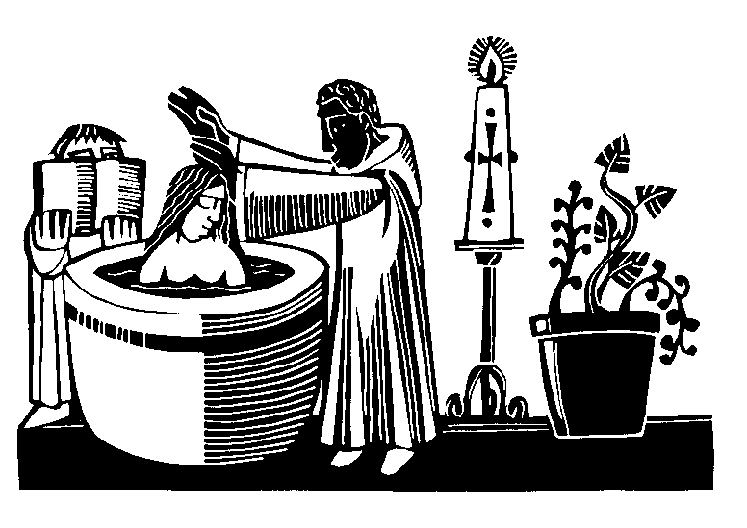
Now that we have completed our observance of Lent, we renew the promises made at our baptism, affirming our allegiance to Christ, and our rejection of all that is evil.
Therefore I ask these questions:
Do you turn to Christ?
I turn to Christ.
Do you repent of your sins?
I repent of my sins.
Do you reject evil?
I reject evil.

And now I ask you to make the profession of Christian faith into which you were baptized, and in which you live and grow.
Do you believe and trust in God, who made you and all life?
I believe and trust in him.
Do you believe and trust in his Son Jesus Christ,
who redeemed you and all mankind?
I believe and trust in him.
Do you believe and trust in his Holy Spirit,
who gives life to you and all the people of God?
I believe and trust in him.
This is the Faith of the Church.
This is our Faith.
We believe and trust in one God,
Father, Son, and Holy Spirit.

Almighty God, who through the resurrection of our Lord Jesus Christ has given us the victory, give you joy and peace in believing; and the blessing of God almighty, the Father, the Son and the Holy Spirit by among you and remain with you always. Amen.

Go in peace to love and serve the Lord. Alleluia! Alleluia!
In the name of Christ. Alleluia! Alleluia!

Prayer for the week
God of life and love:
As we celebrate the Resurrection of your Son, we remember that the joy of Easter Morning came only after the sorrow of the Cross, the darkness of Good Friday, and the silence of the tomb.
As you reassured Mary in the garden, make yourself known to all who struggle to be joyful today; and show us, as you promised your disciples, that wherever we go, you are there before us, and will remain with us always.
Amen.
Canon Carol Wardman

