Press Release: Pamper Evening in Cilmery
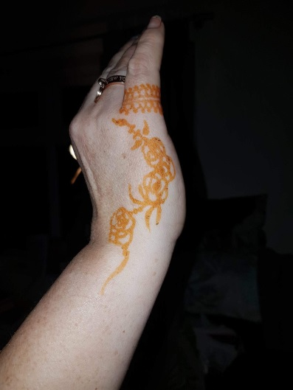 Pamper Night in Cilmery
A Pamper Night was held in Cilmery Village hall on 28th April when professional therapists delighted their customers with Aromatherapy by Elaine of Ashfield Aromatherapy, Hair and Facials by Christine and Vicki from Century Marks in Builth Wells, Eyebrows and Henna Art by Sita Gaha from Paradise Salon in Brecon, Nails by Kate from the Beauty Patch (Llangammarch Wells), Reflexology by Christine Johnson and Gentle Massage by Tessa Dunn. The Body Shop were also in attendance with a range of products to try and to purchase.
A raffle was held and refreshments were served in the afternoon with cakes from Penny of Top Tier Cakes and in the evening there were also a range of wines and nibbles. All departed looking wonderful and feeling relaxed at the end of the fun evening and over £400 was raised for local churches.

